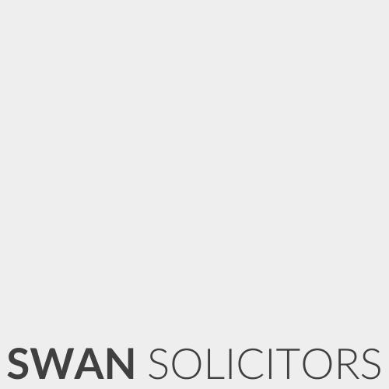

Our Ref: 01200- Anna.Jammeh
Date: 01/04/2026

To the Engineer
By email only

Vehicle Inspection Instructions
Dear All

Our Client: Miss Anna Jammeh
Client Address: 12A Thorneycroft Road, Bilston WV14 8LT
Client Contact Tel: 07534541785
Vehicle Reg: KY70 RLZ
Vehicle Location: Claimant’s home
Accident Date: RTA - 18/03/2026

We refer to the above matter in which we act for the Client who was involved in a road traffic accident on the above date. We kindly request that you arrange inspection of the Client’s vehicle and provide us with a copy of the same on completion.
In the report, please advise whether the vehicle is beyond economic repair, or whether it is repairable.
Please kindly note that these instructions are sent in accordance with terms and conditions as agreed between us previously, namely that the cost of the report will be paid on successful conclusion of the claim. We would ask that if the repair costs turn out to be under £150, please contact us prior to completing the report.
Kind regards

Swan Solicitors

